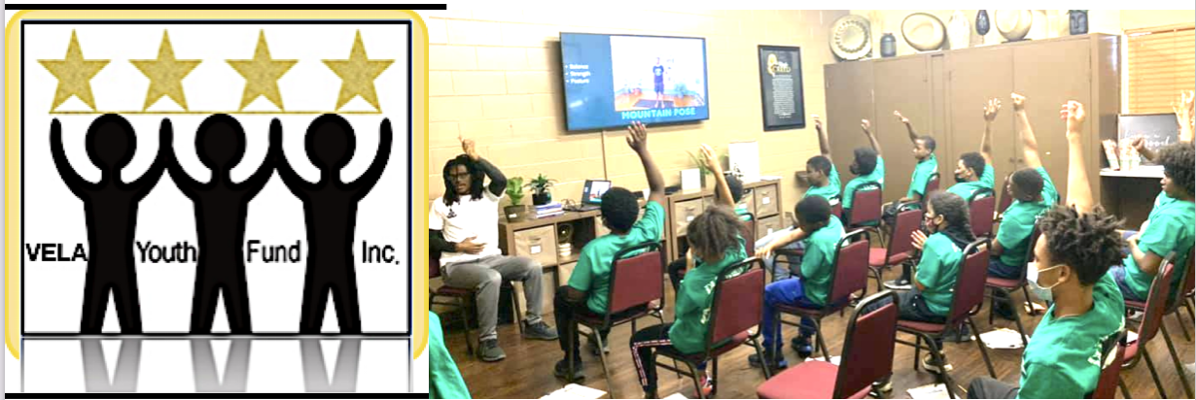

VELA Youth Fund, Inc. is offering Honorarium Awards to graduating high school students and first year college students of African American background who are affiliated with our partner organizations, and are studying within the Coachella Valley. Students should be willing to provide volunteer service to support younger students who are in our partner programs. Our current and prospective partners are BRAAF (Building Resilience in African American Families); located in Palm Springs, CA., First Baptist Church of Indio, CA., and those churches or non-profits who support or adopt VELA's Black Youth Development (BYD) Program. Examples of honorarium service are: performing clerical tasks in support of the BYD Program Facilitator, tutoring/coaching middle school aged students, performing various clerical tasks in support of our BYD Program, and providing clerical assistance in improving and marketing VELA's social and academic development programs.

This year, Honorariums in the amount of $1,000 each will be extended to
“Six Students” who are successful applicants for the 2022-2023 VELA Honorarium Award.

Awardees will agree to provide community service as described above,
and understand that the $1,000 remuneration will be provided in exchange for such service.

Awardees will also agree to appear in social media platforms supported by
VELA Youth Fund to help in the marketing and publicity of its Black Youth Development and Community Service Projects.

Please complete the attached application, and return in a 9 X 12 size
envelope to: VELA Youth Fund, Inc.
35937 Rosemont
Palm Desert, CA 92211

*Please Submit Your Completed Application by May 2, 2022
VELA SCHOLARSHIP AND HONORARIUM APPLICATION

First Name:__________________________________________

Last Name:_________________________________________

Mailing Address:
Street:

_______________________________________________________

City: ____________________State:___________ Zip:_________________

Daytime Telephone Number:__________________________

Email Address:____________________________________________

Date of Birth:

Month:______________________Date:_________________ Year:____________

Gender: ___________________________

Cumulative Grade Point Average: (GPA) ____________________

*(Attach proof of GPA… Your most recent school transcript is required).

Name of High School or Institution Currently Attending

____________________________________________________________

List any current or past places of employment

____________________________________________________________

____________________________________________________________

Name of College, University, or Technical School Where Currently Enrolled or You
Plan To Attend

____________________________________________________________

Your Planned or Current Field of Study_____________________________

_____________________________________________________________

List your hobbies, outside interests, extracurricular activities and school-related activities

_____________________________________________________________

_____________________________________________________________

_____________________________________________________________

List any non-school sponsored volunteer activities you are currently involved with or have been involved in your community

______________________________________________________________

______________________________________________________________

Why is getting a good education important to you, and how will you use your education to help others in your community?

______________________________________________________________

______________________________________________________________

______________________________________________________________

How have others used their education to help you personally? These “others” can be either Adults or Peers or Both

______________________________________________________________

______________________________________________________________

______________________________________________________________

______________________________________________________________

Give examples of some personal experiences where you have been able to help others in your community

_________________________________________________________

_________________________________________________________

_________________________________________________________

What is your experience tutoring/coaching and/or mentoring younger children?

________________________________________________________

________________________________________________________

________________________________________________________

Describe your ability and willingness to work with local churches and nonprofit organizations who help support youth development (e.g., BRAAF Program)?

_________________________________________________________

_________________________________________________________

_________________________________________________________

(Please select ONE essay topic, write a ONE PAGE essay, and attach to your Completed Application).

ESSAY TOPICS –1 Page Essay – Type Written – 14pt font, Normal Spacing –
(approximately 400 words)
- Describe a facet of your identity, background or story that is essential to who you are. For this essay, try finding a part of your identity that will set you apart from others, and highlight the unique perspective you will bring to your educational experiences.
- Write about “Gratitude”.
Reflect on something that someone has done for you that has made you happy, thankful and grateful. Describe how gratitude has inspired or motivated you to give back to others.
- Describe something you’re passionate about. How do you plan to learn more about it? What makes it so appealing? Reflect on something that you are passionate about, and tell what makes it so special to YOU. Talk about that thing that you love, or that obscure topic you’re an expert on — anything, as long as your passion shines through in your writing!
- Tell us the best advice you’ve ever received! Who gave you this advice? How did it change your life and affect how you will advise others? Describe how this advice was specific and personal to you. Explain why it was so important, and connect it to a specific example or examples.
- Based on your experiences, what advice would you give to an incoming high school student? In this essay, try to stay positive. Give advice about helpful things that the student could do to make their high school experience more successful. Emphasize positive parts of your own high school experience, and give advice on how to deal with possible high school challenges. Be honest about your high school experiences, and how they shaped your perspectives and attitudes toward school and your education.
- Talk about a person in your life who’s provided you with greater self understanding and self development. Give a few examples of how this person has influenced you. Conclude your essay by describing how you have a better understanding of yourself as a result.

